**ELE 639 Lab 3: Control of Servo-positioning Module**

**Summary:**

In this lab, we implemented different types of controller to examine the control of a servo-positioning module. A PID controller was tuned to improve the performance of the closed-loop system and the servo was adjusted to meet desired transient and error response specifications. In part 1, an uncompensated proportional-only controller with unity gain was used. A nominal range was considered, with some specifications for amplitude and phase angle. When output was 50 degrees, the dead zone became apparent, as the system reached saturation. This shows that P only control was unable to produce a linear invariant system since the settling time was not close to what was expected.

In part 2, we changed the system gain to different values to improve the tracking of the servo module, with a compensated P and PID controller. We noticed that increasing gain decreased the steady-state error and the rise time, but the PO and settling time increased. We implemented the Ziegler-Nichols “Ultimate Gain” Method to finally determine the specs using the modified method formulas, for Kp, Ti and Td. We noticed that the settling time and error decreased for the PID controller. The Anti-windup controller caused the PO to be decreased. However, the steady state error was increasing, thus PID was chosen.

For part 3, the non-linear effects of saturation were examined as the system moved out of the nominal range, in terms of its amplitude of the input. We observed a large change for the uncompensated systems, due to saturation for an input pulse of 300 degrees. It was obvious that in the nominal range, the compensated system had better settle time and rise time when compared to the same systems in the saturated regions. The anti-windup decreased the PO again, but with the addition of rising time, settling time, error and settling time this time. For an input of 20 degrees, the uncompensated system had an improved PO while the compensated demonstrated better rise time, settling time and steady-state error. Moreover, the PIDA controller had a higher rise and settling time but had a zero-state response.

**Part 1: Uncompensated Servo Module Response**

1. The response of the uncompensated servo system in the nominal range is as follows:

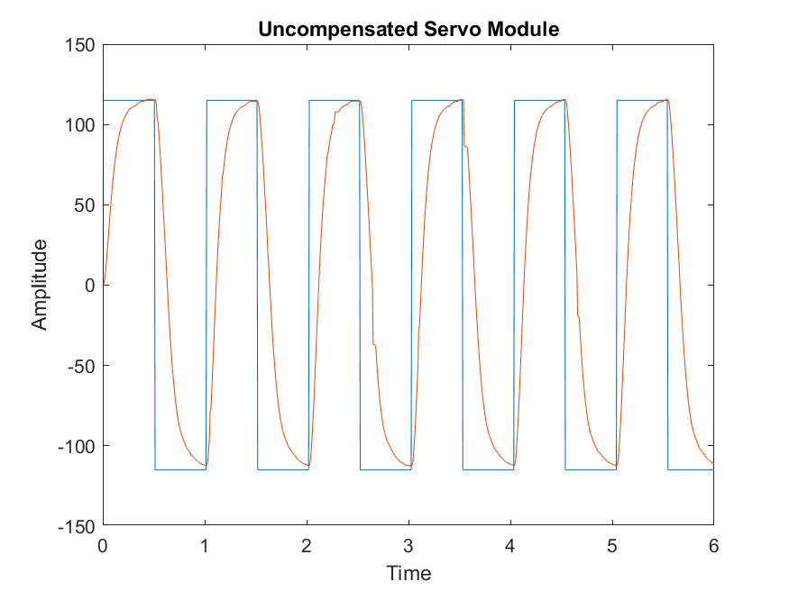 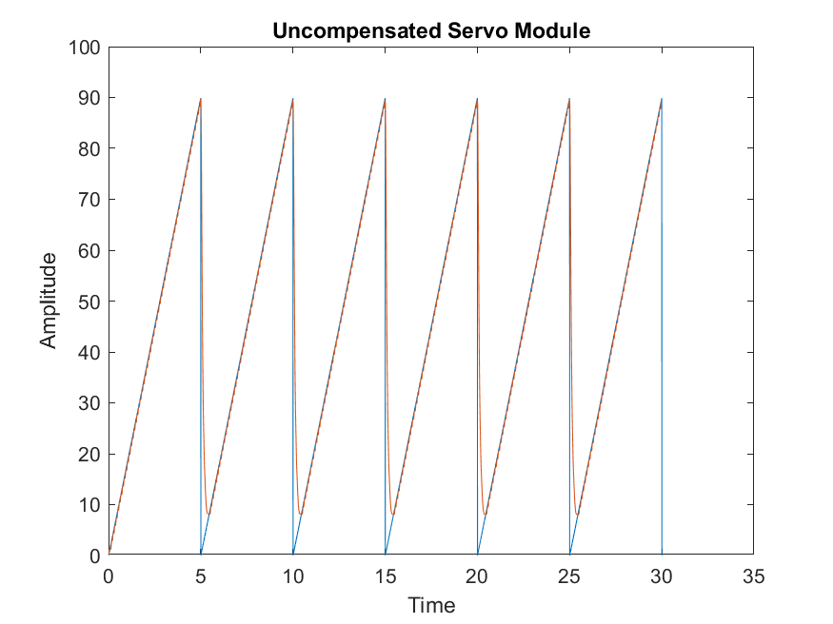

**Figure 1.1: Uncompensated Servo (Square Wave) Figure 1.2: Uncompensated Servo (Ramp)**

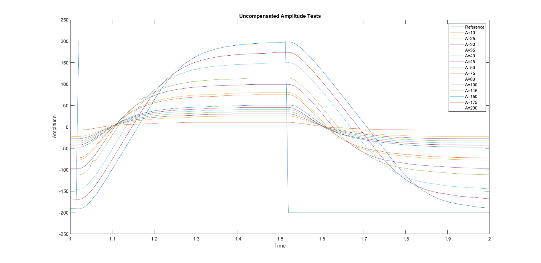

**Figure 1.3: Uncompensated Servo Amplitude Test for A = 10 to A = 200**

1. The nonlinearities present in the square wave response are evident just by observing the Figure 1.1 above. The errors are a result of only implementing a Proportional controller. However, when a PID controller is being implemented, the main proportion of control is handled by Proportional controller.
2. The nonlinearities are caused by the dead-zone effect, as it is evident just via observation. Tweaking the Kp value adjusts the effects on the system. Since a P controller is being used, gain is the only adjustable parameter and thus makes it a limiting factor towards making nonlinearity too difficult to accomplish.
3. Below is a table comparing the results achieved from both part 1 with an uncompensated as well as PID from part 2.

**Table 1.1: Parameters for Uncompensated Proportional and Compensated PID Control**

|  |  |  |  |  |  |
| --- | --- | --- | --- | --- | --- |
| System Type | PO (%) | Settling Time (±2%) (s) | Rise Time (10-90%) (s) | Steady State Error (Step) (%) | Steady State Error (Ramp) (%) |
| Uncompensated P Control | 0 | 0.0001 | 0.1533 | 1.1336 | ∞ |
| Compensated PID Control | 5.28 | 0.0002 | 2.2 | 1.0506 | ∞ |

1. The system type is a Type 0, as it is evident by observing the step and ramp response of the system. The steady state error of the system response backed the system type. In Type 0, the steady state error of the positional gain is always a constant value. The step and ramp response conform to the expected values for Type 0. This is corroborated by the values in Table 1.1. Also, a system Type 0 has an infinite steady state error unlike Type 1 which has a constant ramp response.

**Part 2: Compensated Servo Module Response**

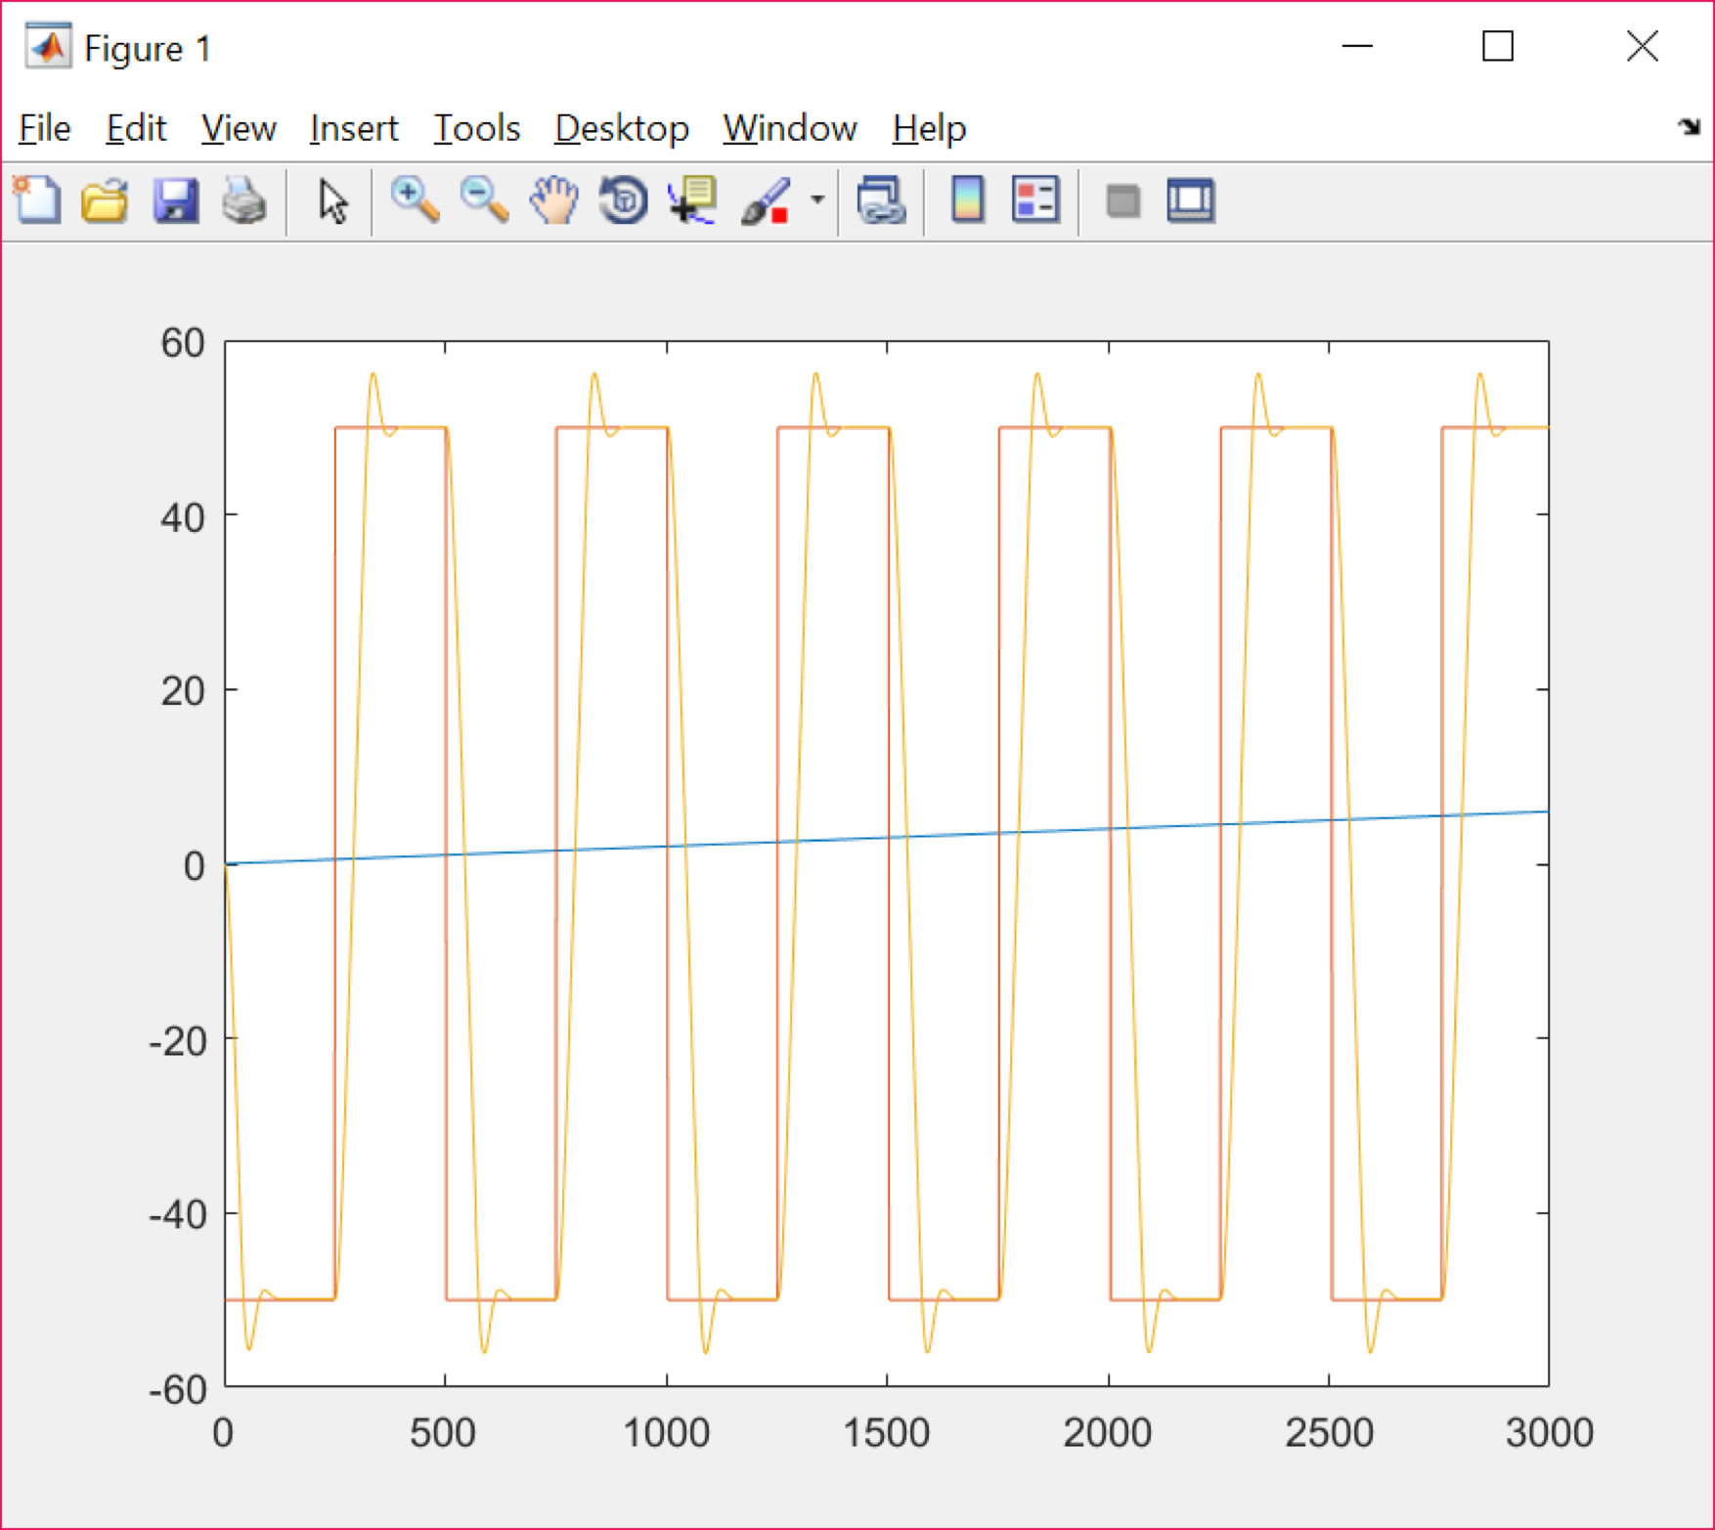

Figure 1: Compensated Proportional step response for gain= 3

Figure 2: Compensated PID step response for critical gain= 35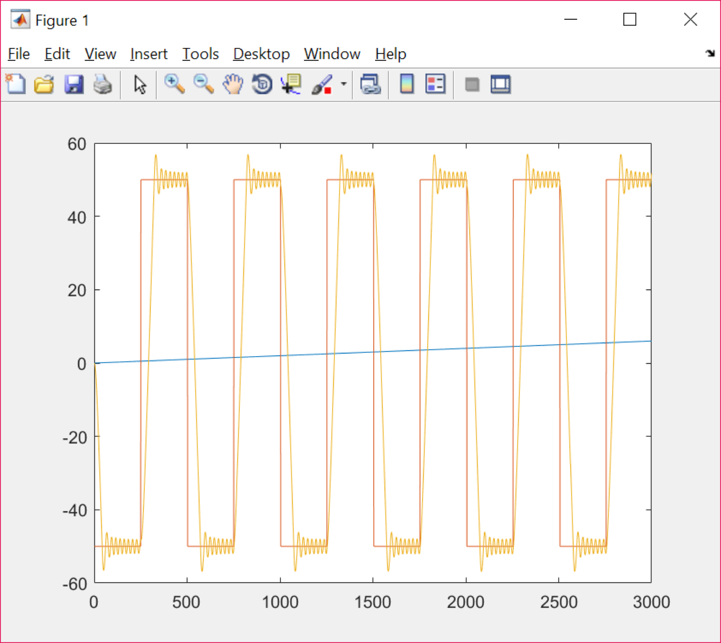

Figure 3: Proportional Compensated Ramp response with gain = 5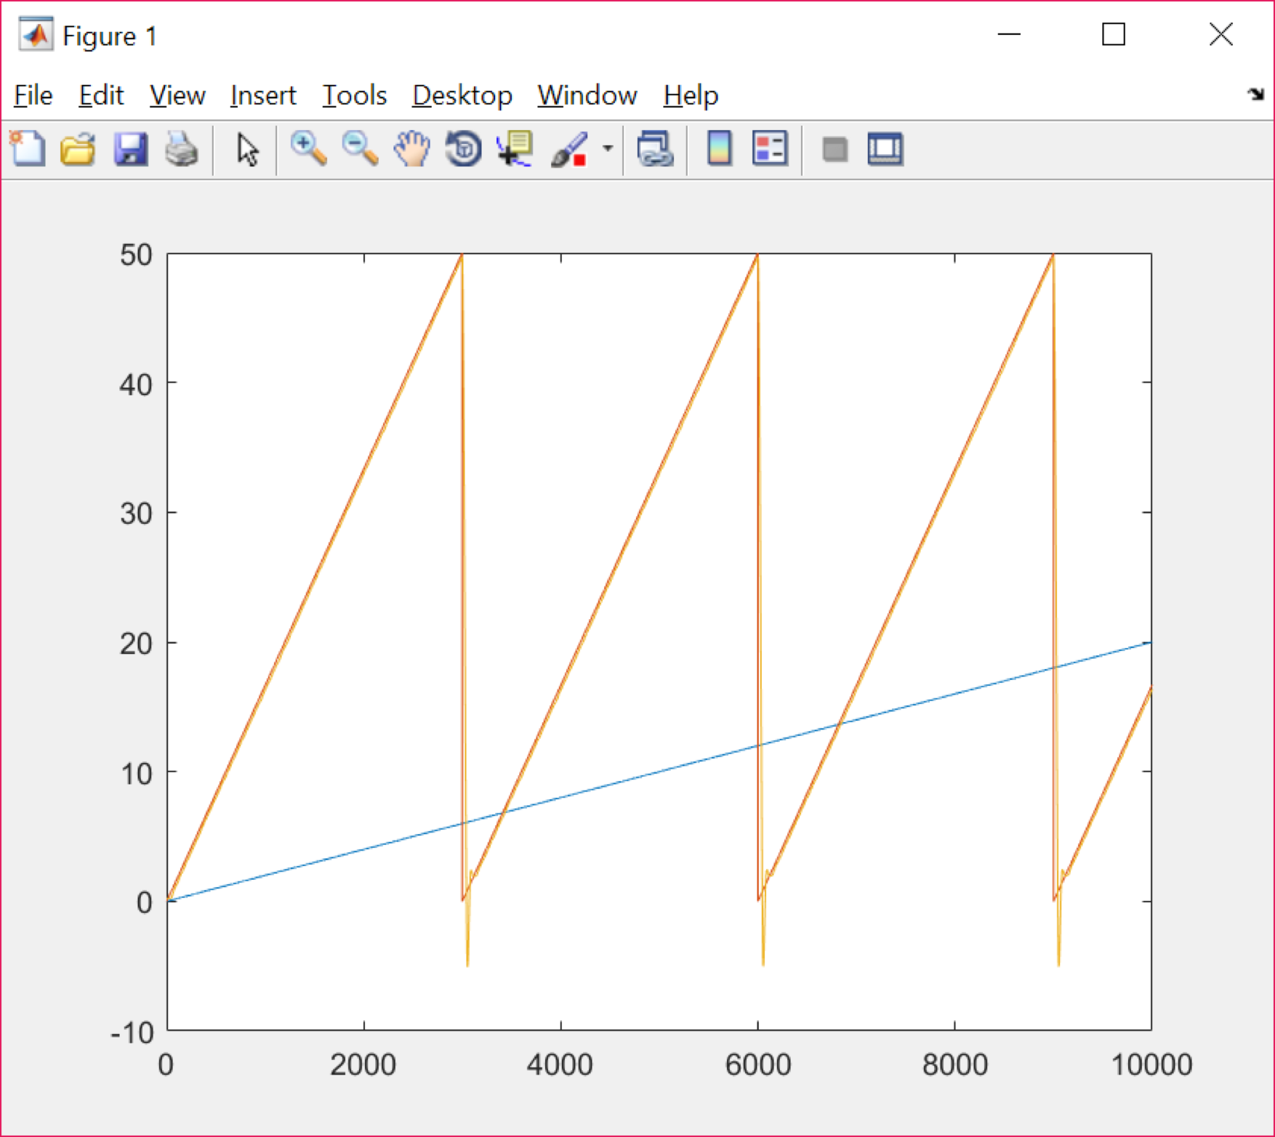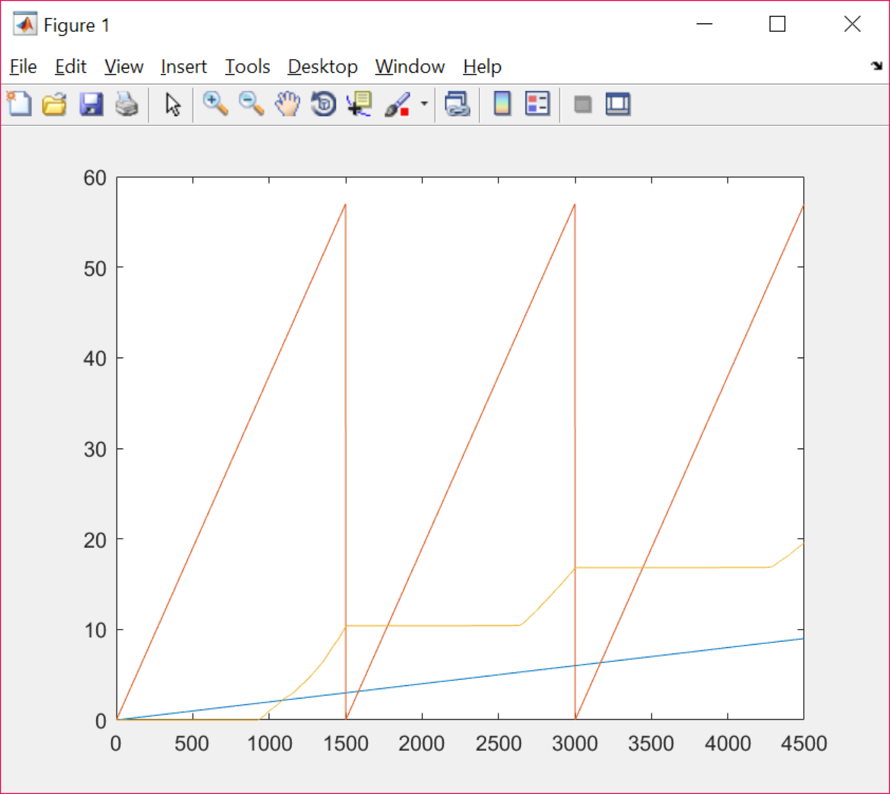

Figure 4: Proportional Ramp response with in the dead zone with very low gain

1. The proportional controller could not meet the specifications of the rise time,PO, and settling time as stated at the beginning of the experiment. However, the PID controller met the requirements closely as steady state error was brought to a minimal, because of the integral control. The difference can be noted between Figure 2 and 3 against Figure 1 for step input.
2. The Ziegler Nichols Ultimate gain method was used to process the PID parameter Kp,Ti and Td using the modified method formulas. The controller had a 115 degree step input,and a marginally stable gain was found that was taken as 35,as shown in Figure 2. The period of oscillation was taken measured from the graph and was found as 0.05 seconds (from 385.40 seconds to 385.35). Using these values, the rest of the a parameters were determined for the PID controller using the following equations:

K= 0.6Ku Ti = Pu/2 Td = Pu/B

3) Did you experiment with the Anti-Windup Controller setting? Did it make a difference in your compensated system response?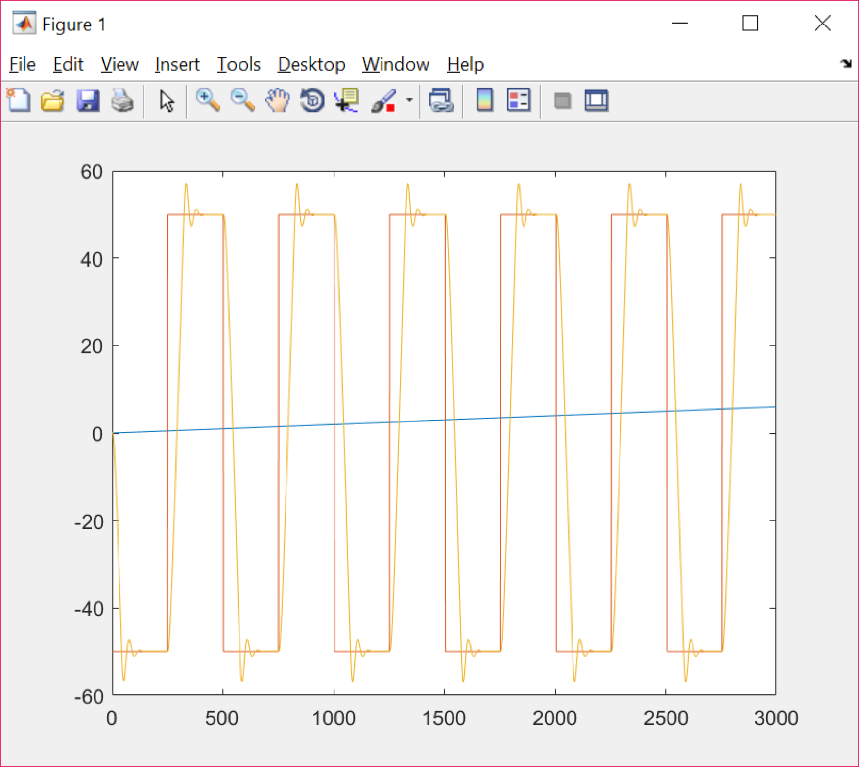

Figure 5: PIDA step input response

Figure 6: PIDA ramp input response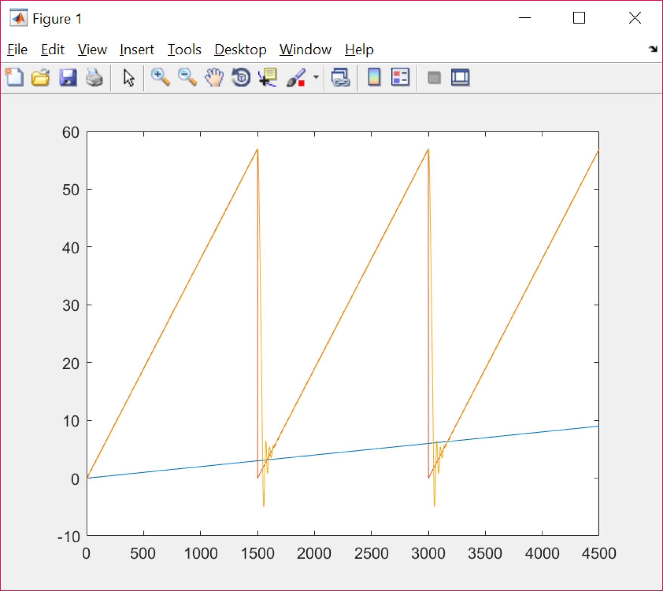

The Anti-windup controller turns the integrator of the servo-positioning module off to avoid the apparatus to get damaged, as the system is already in the saturation mode. This prevents the percent overshoot to be very high as the transient response initially would be high if the buildup of energy in the integrator can be reflected in the system, due to saturation. Therefore, the anti-winding system caused the percent overshoot to decrease slightly without affecting other parameters. The controller was not in saturation mode during the nominal range was chosen, which is why a small difference in Percent Overshoot is noticed.

4) What were the final settings of your Controller that gave you the "best possible" response for the nominal range of pulse inputs?

The best possible values for the PID obtained using the modified method are Kp = 20, Td= 0.0063s and Ti= 0.025s. The graph with a 50-degree step input with the desired specifications can be seen on Figure 3 above.

5) Present the "best possible" response of your compensated servo system in the nominal range. How did you adjust the controller parameters to ensure the compensated system response is as close to being linear as possible? Compare the uncompensated specs with the “best” Proportional Control and with the “best” PID Control settings.

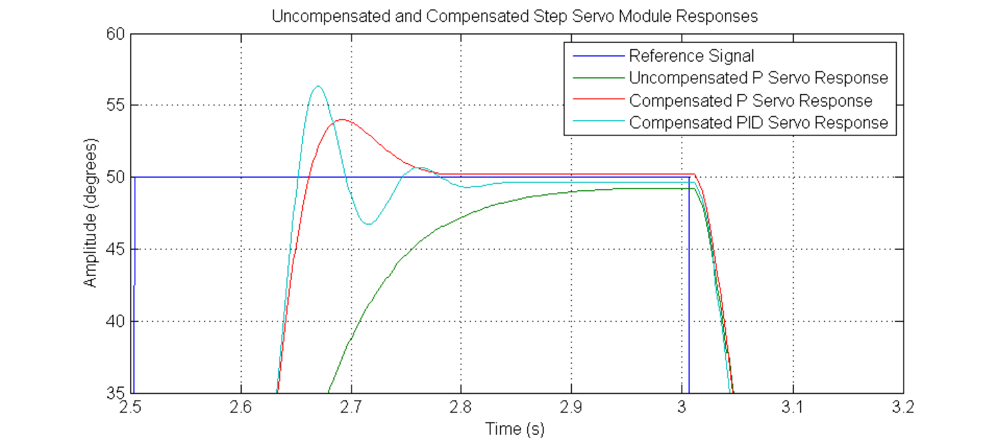

Figure 7: Compensated and Uncompensated P and PID step responses

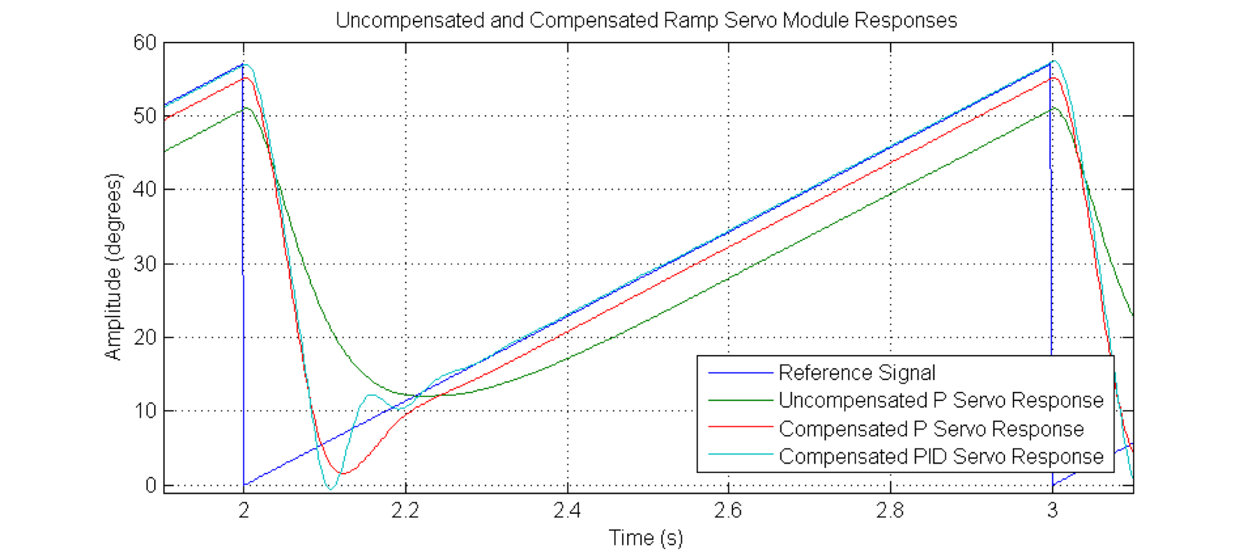

Figure 8: Compensated and Uncompensated P and PID ramp input responses

The Zeigler-Nichols Method was used to find the best possible response of the compensated servo module. The parameters were then adjusted to get as close to a linear response as possible. The specifications close to the requirements are outlined in the table below:

Table 2: Performance specifications for the uncompensated and compensated P and PID servo system

|  |  |  |  |  |  |
| --- | --- | --- | --- | --- | --- |
| **Performance Specifications** | Percent Overshoot P.O. | Settling Time tsettle(±2%) | Rise Time trise(10-90%) | Steady State Error ess(step)% | Steady State Error  ess(ramp) |
| **Uncompensated Servo** | 0% |  |  |  |  |
| **Compensated Servo (P Control)** |  |  |  |  |  |
| **Compensated Servo (PID Control)** |  |  |  |  | 0 |

6) Discuss the improvements in the system response under P, then PID (or PID+A) Control, as compared to the uncompensated system. Consider both the steady state tracking (i.e. discuss the steady state errors) and the transient performance.

We noticed that the anti-windup controller (PIDA) setting improved the square wave input, although the rise and settling time decreased slightly.

**Compensated Servo Module Response outside the Nominal Range- Part 3**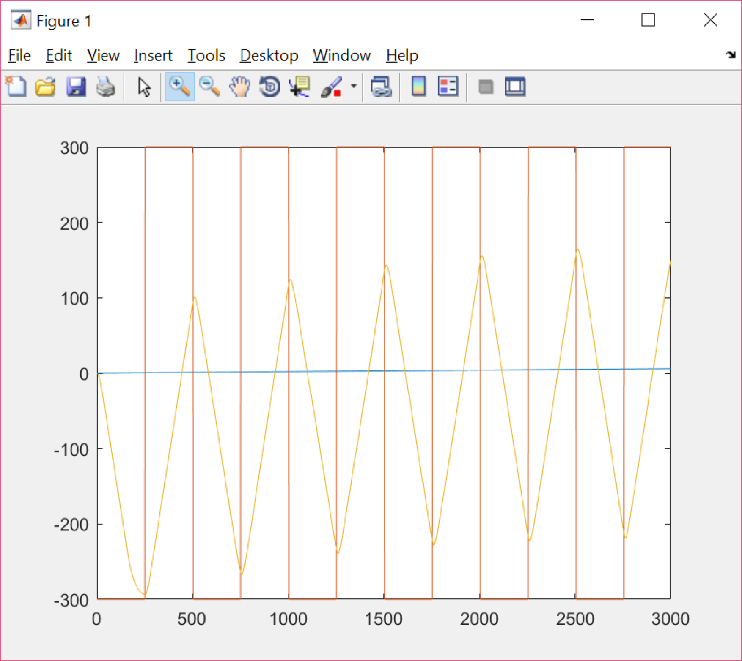

Figure 9: Servo output with square wave with amplitude of 300 degrees for P

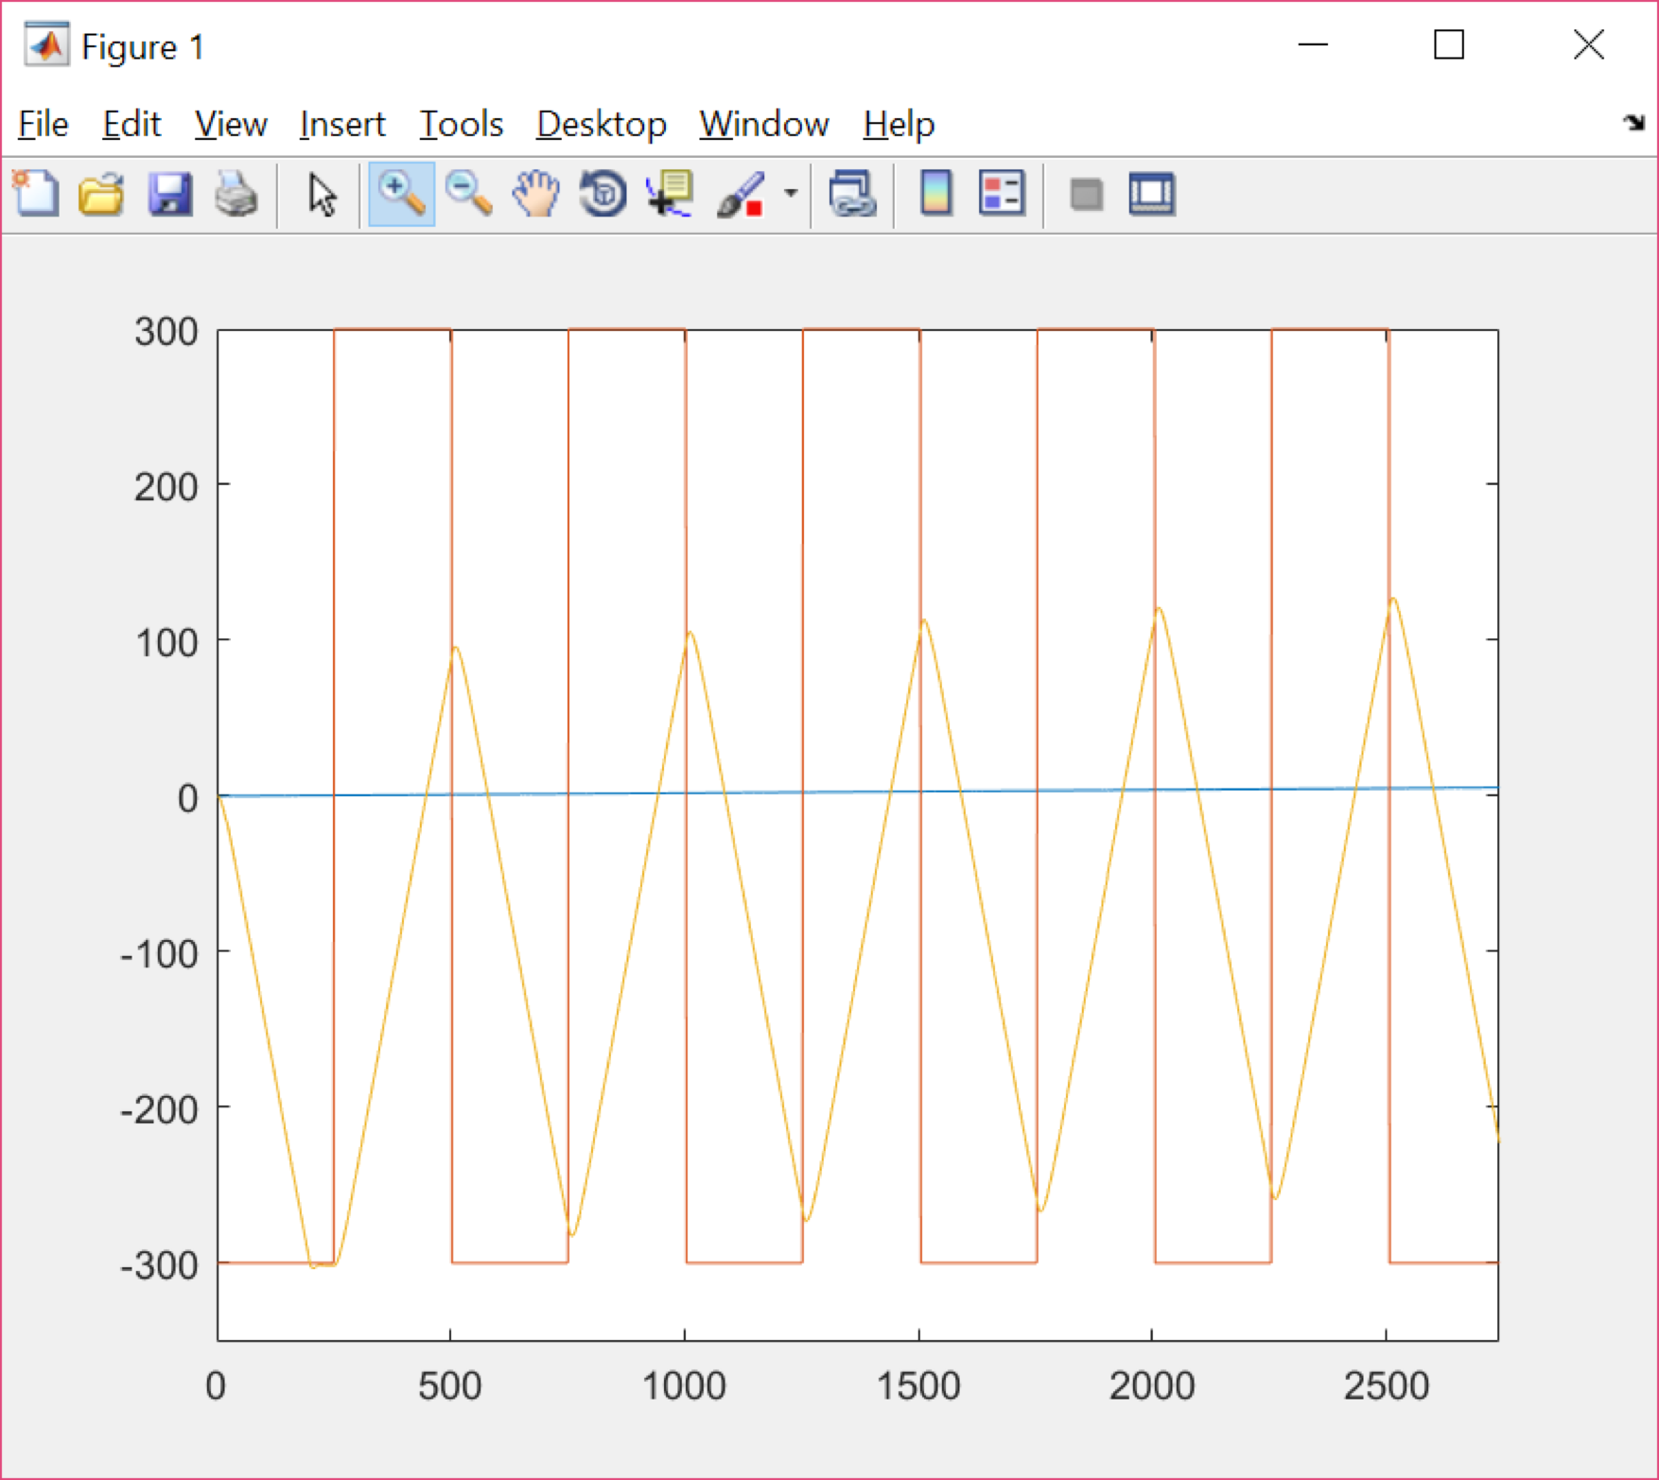

Figure 10: Servo response with square wave input with amplitude 300 for PID

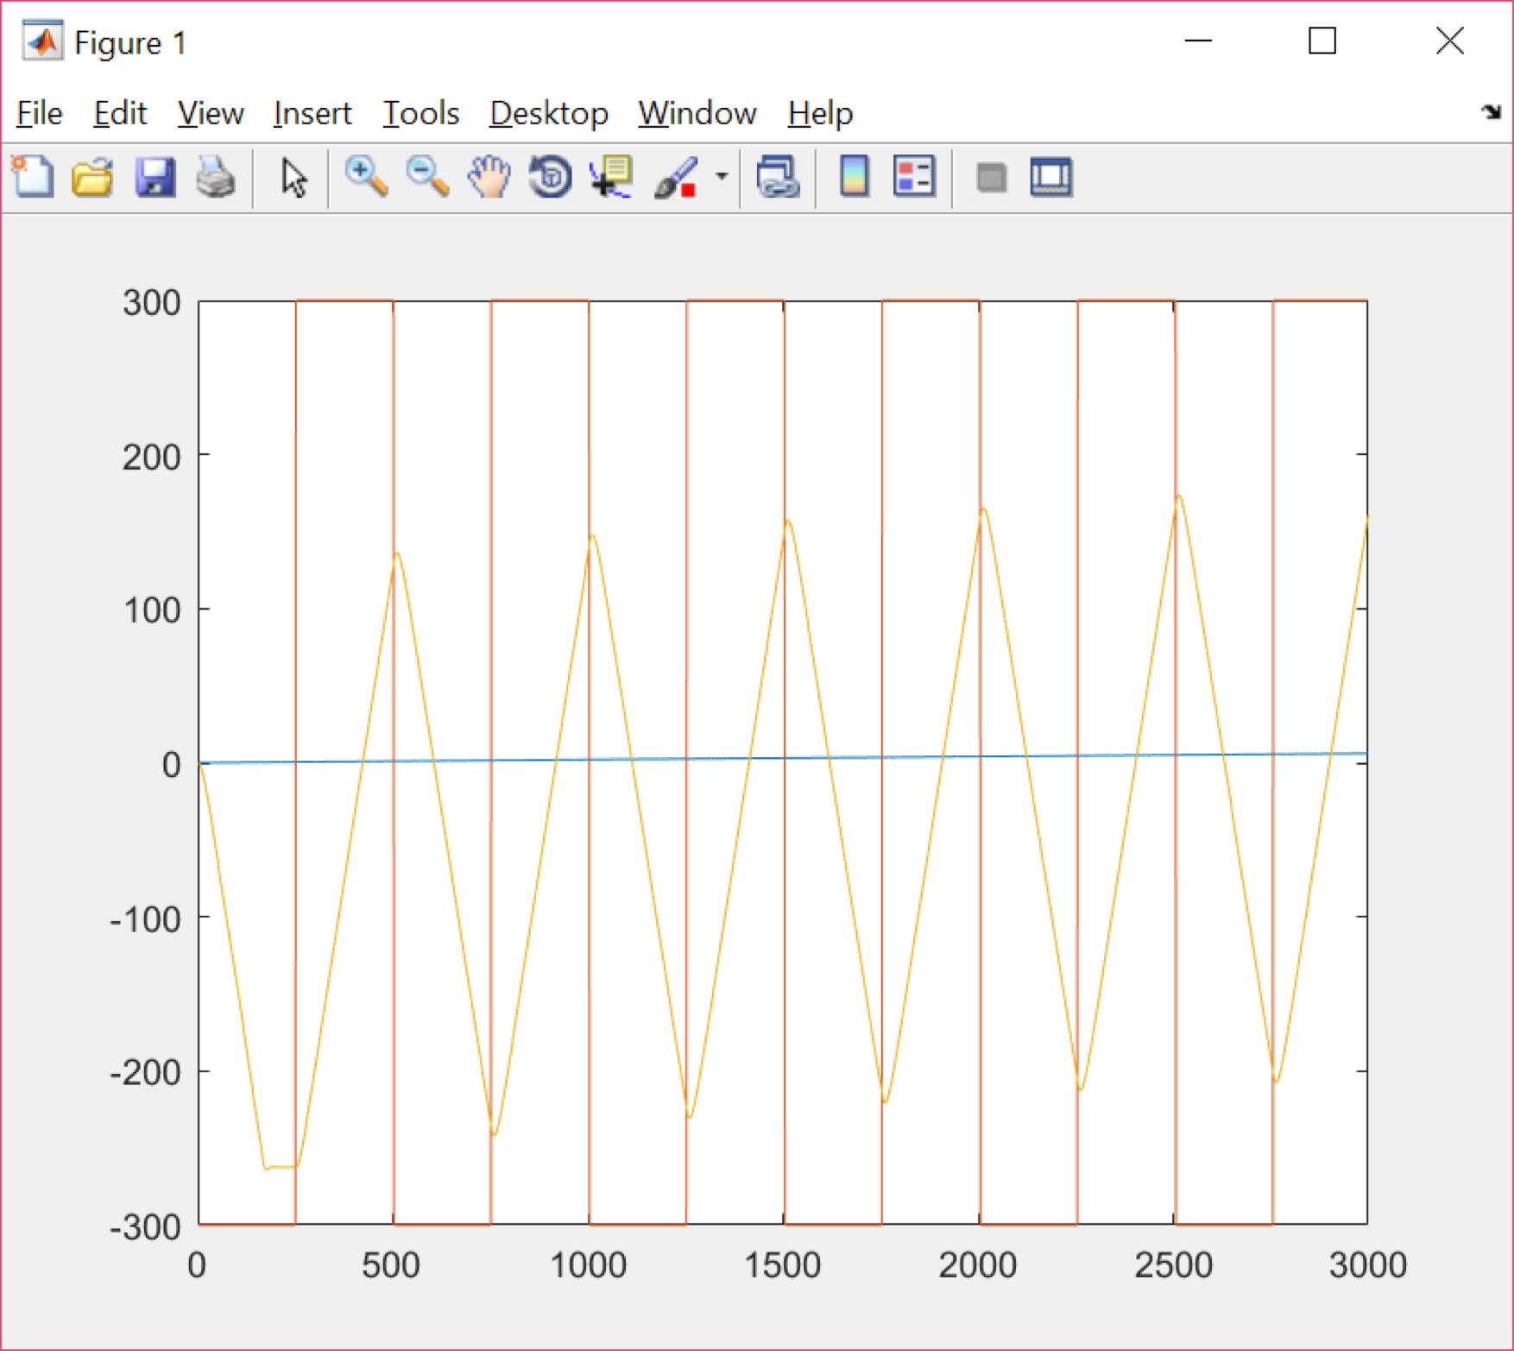

Figure 11: Servo response with square wave input with amplitude 300 for PIDA

Looking at Figure 9 and 10,we can notice that both systems are saturated, although the uncompensated system of Figure 9,with shows larger effect from saturation, than the compensated PID response.

***Table 3****- Step response characteristics of saturated systems*

|  |  |  |  |  |
| --- | --- | --- | --- | --- |
| **System** | Percent overshoot | TRise(10-90%) | Tsettle(±2%) | ess(step)% |
| **Uncompensated** | 0% |  |  |  |
| **Compensated PID** | 0% |  |  |  |
| **Compensated PIDA** | 0% |  |  |  |

The performance of the two kinds of systems depicted similar percent overshoot with close steady state error, while the rise and settle time were slightly better for the compensated system, in terms of the required performance specifications aforementioned in the lab.

The uncompensated system demonstrated better rise time, settling time but higher percent overshoot in the nominal range, compared to the saturated system above. The compensated system had better PO, faster rise and settling time, demonstrating zero steady state error response. 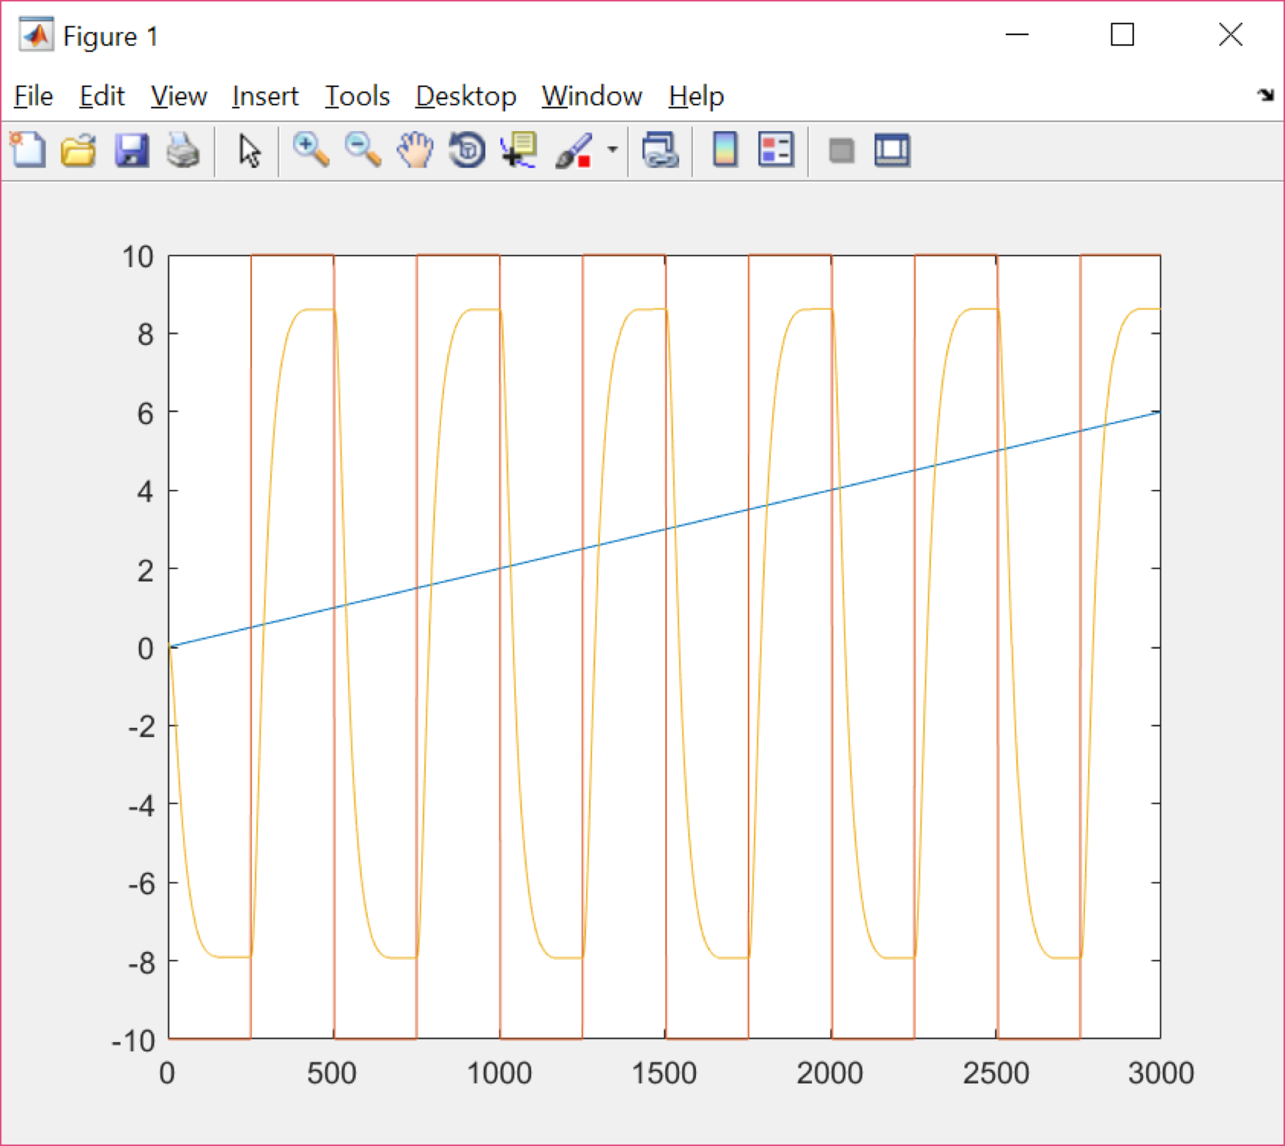

Figure 12: Servo Response for square input with amplitude of 10 for P

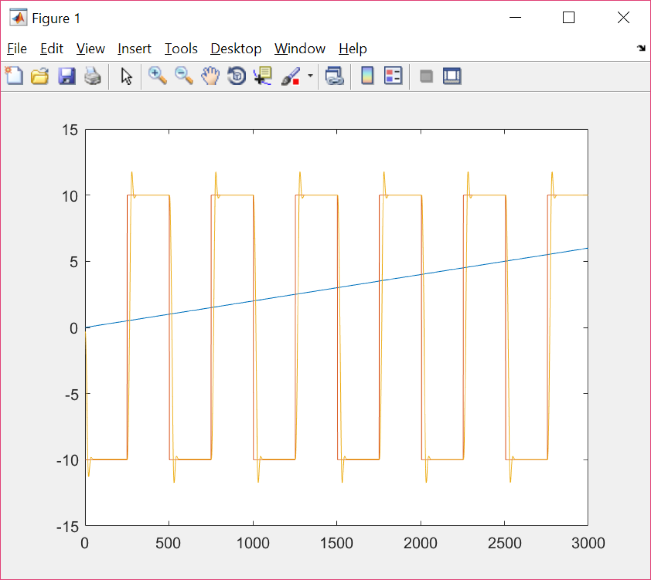

Figure 13: Compensated Servo Response for square input with amplitude of 10 for PID

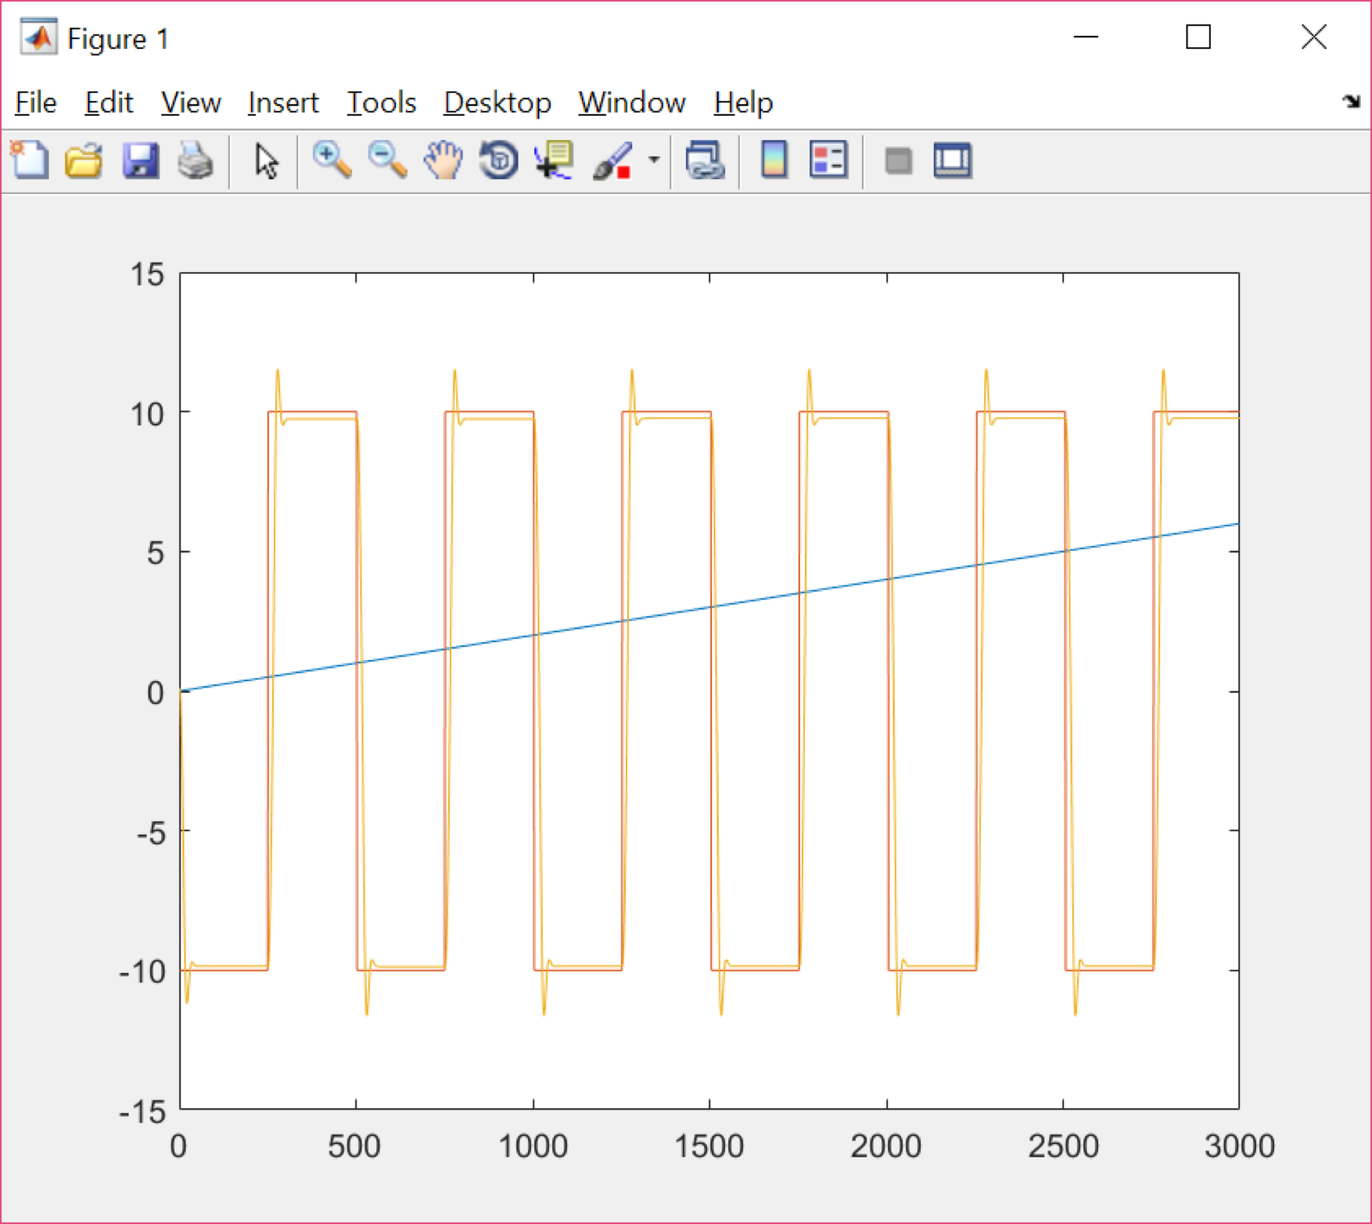

Figure 14: Compensated Servo Response for square input with amplitude of 10 for PIDA

Comparing the effects of the amplitude being 10 for the square wave input, it was seen that the uncompensated system hit the dead zone while the compensated, does not.

***Table 4****- Step response specifications of systems operating outside the nominal range (±10°)*

|  |  |  |  |  |
| --- | --- | --- | --- | --- |
| **System** | Percent overshoot | TRise(10-90%) | Tsettle(±2%) | ess(step)% |
| **Uncompensated** | 0% |  |  |  |
| **Compensated PID** |  |  |  |  |
| **Compensated PIDA** |  |  |  |  |